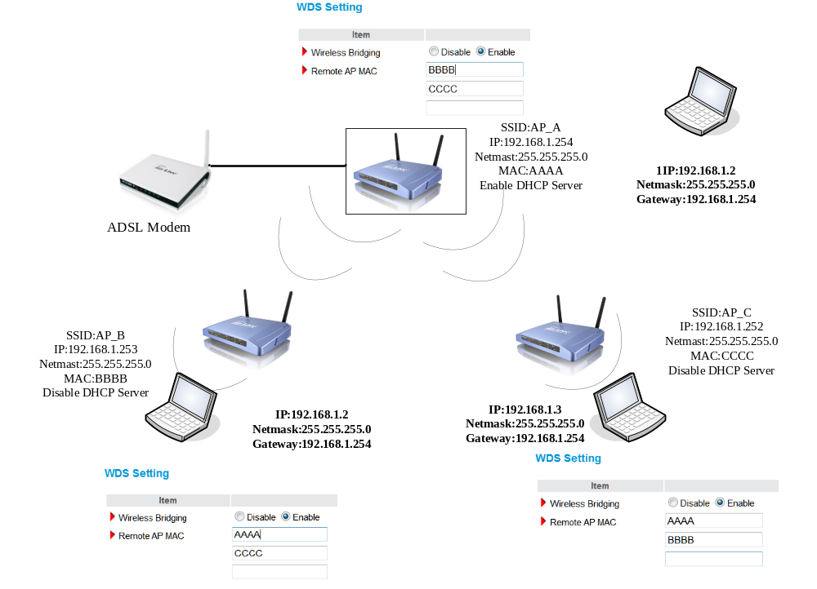

- 3 AP and PC is at same LAN. For example:192.168.1.0/24
- 3 AP Default Gateway IP is different.
For example:
AP_A is192.168.1.254
AP_B is192.168.1.253
AP_C is192.168.1.252

3.1 3 AP use WDS Repeater Function.
3.2 SSID can be different.
3.3 Wireless Channel must be same
3.4 If you have set Wireless security the 3 AP must be same.
3.5 The one AP input other AP’s MAC and must be correct.

- only the AP which is connected ADSL Modem can enable DHCP Server.
- Check your ADSL Modem can access the internet as same as the connected AP.

